# **Landing Page**

**Welcome to Purgatory, where we love comics and hate cops.**

Purgatory Comics Press is a comics publisher based largely on the East Coast. We are a community of anti-fascist, artist-owned global comics and related media in a variety of genres. Purgatory is committed to PACBI.

Purgatory Comics Press, LLC is owned by Lars Allen.

Read more [link to about]

**Submit to Purgatory**

To learn more about what we publish and how to get published, check out our submission requirements! [link to contact page]

**Comics and more**

[preview of books on sale and merch] [link to merch]

# **About**

**Why Purgatory?**

Our creator has always been captivated by low-brow undisciplined zones of knowledge production.

760-year-old gay Gemini philosophy hag Dante Alighieri wrote the *Commedia Divina*, consisting of 3 parts: *Inferno*, *Purgatorio*, and *Paradiso.* *Purgatorio* is a poem that departs from traditional experiences of texts and moves toward animation and the virtual. In this poem, Dante explores questions of artistic representation, verisimilitude, ambivalence, imagination, mimetic contagion, and the human ability of cognitive extension. In the central canticles of Dante’s Purgatorio, he explores “miei non falsi errori,” or his non-false error (Purg.XV.117). Text-Dante interacts with virtual bodies and virtual sensations, claiming these surreal experiences as errors that are not false. The mind can extend beyond the flesh when interacting with objects; in our case, comics & text objects, and Dante-author attempts to represent the paradox of personal experiences beyond the body in his poem, *Purgatorio*.

Comics are powerful tools to embody knowledge and experiences beyond each individual’s flesh experiences. Purgatory Comics Press harnesses the raw gay Italian power of Dante to produce media that goes against Western claims to truth, using sensation to move our readers.

**Meet Purgatory’s People**

## 

LARS

## 

Founder Lars has devoted their life to comics, typography, and watching cartoons. Lars has been creating, producing, editing, lettering, and publishing comics since 2016. They are especially inspired by the work of Michael Deforge, Inès Estrada, Joe Sacco, and Ben Passmore. [link to lars’ site]

SAM

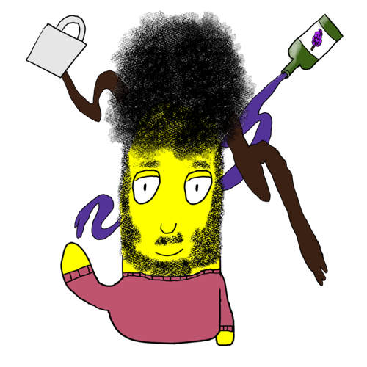

Acquisitions editor Sam is a cartoonist/comics critic hailing from NYC and the creator of humor comic strip, The Shapes. As a reader of the medium since childhood, he proudly wears his newspaper comic influences on his sleeve. His biggest inspirations growing up include the work of Stephen Pastis, Charles Schultz, Bill Watterson, Gary Larson, and Garry Trudeau. [link to sam]

GUY

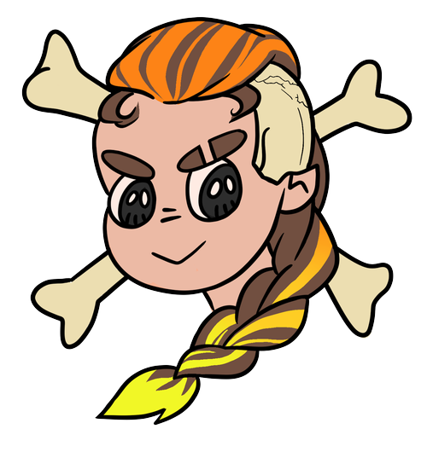

Resident Mathematician and in-house creator Guy fell in love with comics and creating them at a young age. Derivative art holds a special place in Guy's heart and its influence can still be found in Guy's approach to creating the art Guy wants to see in the world. [link to guy]

# **Contact Us**

For general inquiries, email us at contact@purgatorycomicspress.com. For submissions, please check our submission packet requirements before sending us your material at submissions@puragtorycomicspress.com.

# **Submissions**

# **Merchandise**